


Analytical Method Development and Characterization Services Overview
Issue Date: 30 June 2025
Presented to
Biocon Biologics Ltd.
Comprehensive Analytical Capabilities for Biologics Development
Category | Techniques / Capabilities
Routine Testing: | HPLC/UPLC (RP. SE. IE, PA)
 | Capillary Electrophoresis (CE SDS – NR-R, CiEF)
 | iCE, ELISA – process residual (HCP, HCDNA, rProA)
 | HPLC/UPLC (RP. SE. IE, PA)
Product Characterization: | Mass Spectrometry
 | LC-MS (Glycan and product variants)
 | MALDI-TOF, MS/MS (ion-trap)
 | CD fluorescence
 | SPR (Biacore), PAMAS (Subvisible), Solo VPE, Flow cam, Maurice (cIEF) and HiAC
Bioassay: | Cell-based and non-cell-based
 | In vivo
 | Proliferation and Inhibition
 | Reporter gene
 | Effector functions
 | Secondary signalling
Stability Testing: | Exploratory
 | Freeze-thaw
 | Real-time
 | Accelerated, and stress (forced degradation), in-use stability

Approach to analytical development-qualification
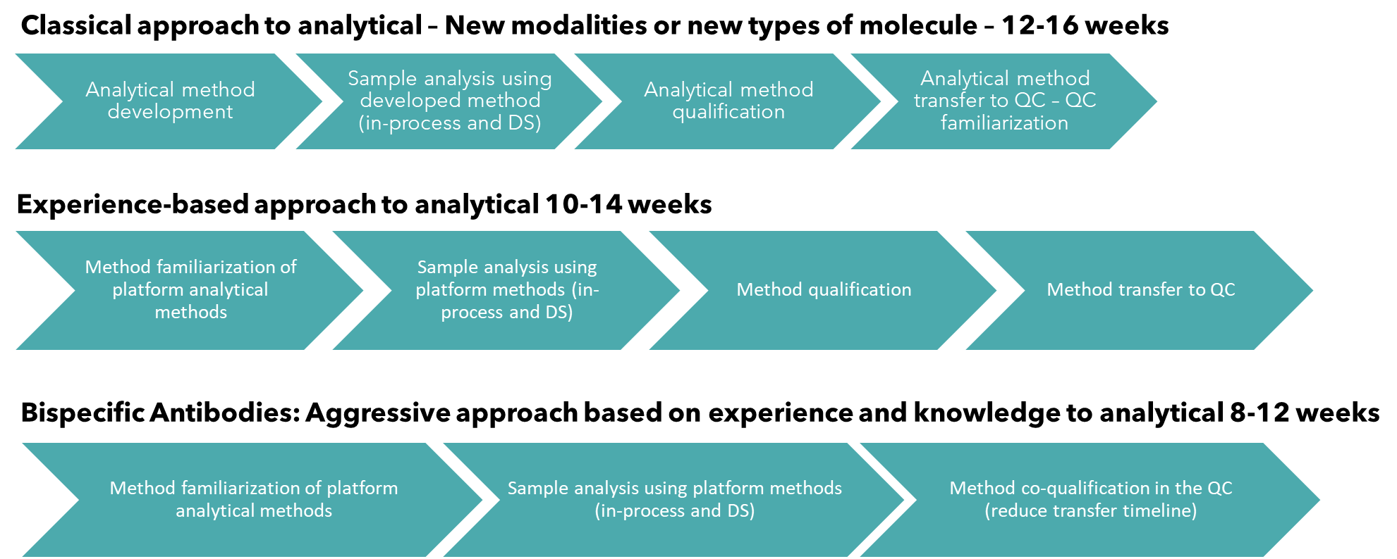

Approach to analytical development-qualification
Attribute | Test | Method
Primary structure analysis | Intact mass analysis by HRMS | Mass spectrometry
 | Reduced Mass analysis
 | 100% primary amino acid sequence coverage using various enzymatic digestion
 | Post translation modification analysis
Secondary structure analysis | Far UV CD | CD spectroscopy
 | FTIR | Attenuated total reflectance-FTIR (ATR-FTIR) based on amide bands
Tertiary structure analysis | Intrinsic florescence | Spectro-fluorometer
 | Extrinsic fluorescence
 |  | With external dye
 | DSC/DSF | Nano DSC/DSF
 | SEC-MALS
 | DLS
 | Near UV CD | CD spectroscopy
 | Di sulphide bond analysis (DSB) | Mass spectrometer
Variants  characterization | Size variants characterization* | Various bio-physical techniques
 | Charge variant characterization*
 | Detailed N- N-Glycan iso form analysis with HILIC UPLC and MS | HILLIC with FLR detection
 | Site-specific glycan characterization | Mass spectrometry
 | Sialic acid content estimation | FLR with external dye
 | Free thiol content estimation | Elman's assay
 | Size variants characterization* | Various bio-physical techniques
* Size variants and charge variants will be characterized using various bio-physical techniques and mass spectrometry .

Lot Release Assays (LRA) Capabilities
Attribute | Test | Method
General characteristics | Visual inspection | Compendial
 | pH | Compendial
 | Osmolality | Compendial
Identity | Peptide mapping | HPLC or UPLC, based on the client's requirement
Concentration estimation | Solo VPE  UV 280 (and any suitable methods, such as RP, Pro-A) | Concentration would be estimated either with customer customer-supplied ex-coefficient or with theoretical values
Size variants | SEC-HPLC | HPLC
 | SDS PAGE | commission training
 | CE-SDS both reducing and non-reducing
Charge variants | IEX | Suitable IEX method
 | iCE | Protein simple
N-glycan analysis | HILIC chromatography with FLR | HILLIC with FLR detection, detailed AF, HF, High mannose, Sialic acid content will be reported
Excipients | CAD, or UV-based, with various chromatography techniques
Product-related impurities | HCP | Kit based
 | HCDNA | RT PCR
 | Protein-A leachates | ELISA
Bioassay | Relevant bioassays | Either ELISA or a cell-based assay

Bioassay capabilities for biosimilars and peptides
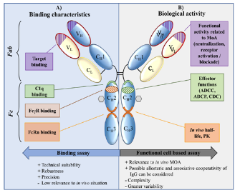
Cell-based Assays:
- Cell-based bioassays for MOA or lot release
  - Proliferation assays
  - Cytotoxicity assays
  - T-cell activation assays
  - Flow cytometry analysis
- Fc Effector assays
  - ADCC, ADCP, CDC
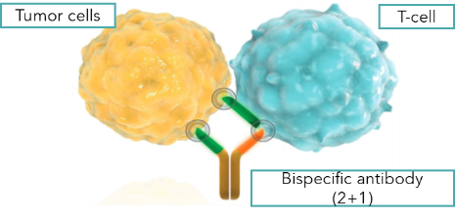
Binding assay:
  - Fab Binding
  - FcRn, Fc gamma I, II, III
  - SPR-based binding assays
Cell-based Assays:
  - T-cell activation assays
  - Flow-based binding assays
  - ELISA-based binding assays for both arms of the Bispecific antibody

